Farber Lab Notebook

**5/24**: Intro to Fish husbandry, self-cross 5 nluc(+/-). Crosses 3 and 4 had two females

**5/25**: Picked eggs from my crosses. 30,30,100,100,52 eggs. Refreshed media for some of McKenna’s fish. Removed shells. Literature search for PRKD2 drug targets.

**5/26**: Made microinjection needles and introduced fish to nursery. Designed CRISPR gRNA primers

**5/27**: designed verification and CRISPR primers. See prkd2_CRISPR primers for more info.

**5/28**: nluc assay. See protocol in protocols folder. Extracted DNA on nluc crosses.

**6/1**: PCR for nluc assay. See protocol in protocols folder. For low used A1, H6, D4. For medium (putative hets) used E7, C3, B7. For homos used F3, B9,D2.

-Practiced injections with Darby. Calibration was really hard.

-Set up a cross tomorrow with AB 12109 tank F08-2-04. Made 5 crosses for plenty of eggs.

**6/2**: Practiced injections again. Someone removed the gates from my crosses so most of the eggs were already 2 cell stage. Very annoying! Getting better at injection, but I need to practice more. Probably will do a cross on Thursday 6/4 to practice again.

Ran nluc genotype gel: Very few bands. Got one heterozygote, which I thought was a homozygote, but was one of the lower values for that phenotype.

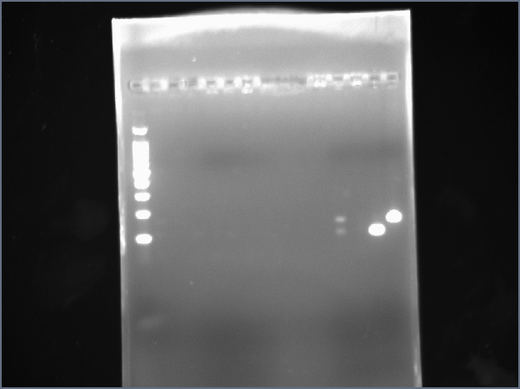

Lane 1: 100 bp ladder, lane 2 sample 1, lane 3 empty, lane 4 sample 2, lane 5 sample 3, lane 6 sample 4, lane 7 sample 5, lane 8 sample 6 lane 11 sample 7 lane 12 sample 8, lane 13 sample 9 lane 14 nluc(+/+) lane 15 nluc(-/-)

Finished drug plan: see document.

Plan for the rest of this week/next week:

Thursday: Set up crosses for drug screen. Start reverse transcription? If not read papers about ApoB and the different CRISPR priming method.

Friday: Practice injections and set up eggs for drug screen

Saturday/Sunday. Come in to check on eggs.

Monday: Set up